**Mineral Security in India’s Defence and Aerospace Supply Chain**

**Current Scenario and Challenges**

The defence and aerospace sectors represent the technological apex of India's industrial ambitions, underpinning national security, regional power projection, and strategic autonomy. These sectors are becoming increasingly mineral-intensive, driven by the adoption of hypersonic platforms, miniaturised electronic warfare systems, directed energy weapons, and advanced jet propulsion technologies. The raw material base sustaining this ecosystem is defined not by volume, but by specificity, strategic importance, and acute supply chain vulnerability.

India’s defence and aerospace minerals landscape can be characterised by high import dependency for all high-purity strategic minerals, with complete external reliance for at least five; No strategic stockpiling mechanisms for elements such as tantalum, rhenium, or niobium; Minimal domestic refining and separation capacity, particularly for REEs, PGMs, and hafnium and inadequate recycling infrastructure for strategic minerals embedded in defence electronics and aerospace scrap.

India’s military-industrial complex currently faces an unprecedented materials bottleneck. The cumulative annual requirement for minerals used directly or indirectly in defence and aerospace applications, including vanadium, hafnium, zirconium, molybdenum, tantalum, tungsten, niobium, rhenium, PGMs (platinum group metals), and REEs (rare earth elements), was estimated to exceed 8,500 tonnes by 2024. This includes aerospace-grade vanadium and molybdenum alloys, zirconium for nuclear-powered submarine cladding, rhenium in jet engines, and tantalum in miniaturised capacitors for missile electronics (Ministry of Defence, 2023; VIF, 2022).

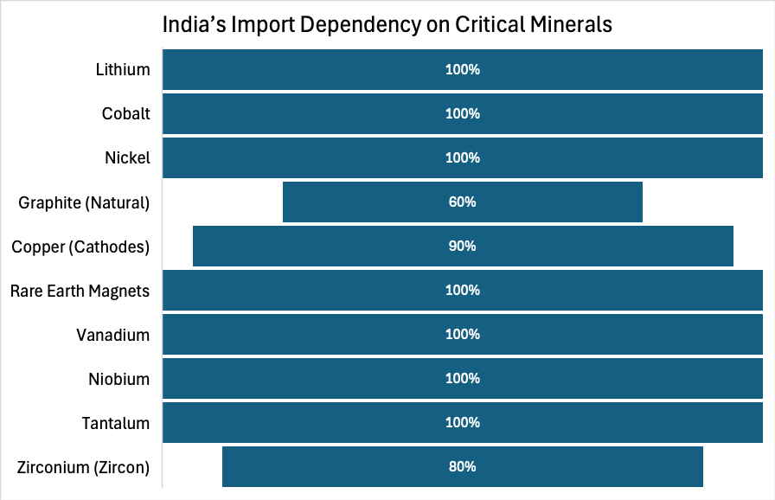

*Data source: Ministry of Mines*

India meets less than 15 percent of this requirement through domestic sources, and some elements, such as hafnium, tantalum, rhenium, and niobium, are entirely import-dependent (IBM Yearbook, 2024, Chapter 13, p.2). For instance, India produced no hafnium in 2023, despite an estimated demand of 250 kg for nuclear and aerospace cladding materials (DAE Annual Report, 2023). The country imported over 11,953 shipments of rhodium between March 2023 and February 2024, an astonishing 733% year-on-year increase that signals rapidly growing domestic demand and insufficient strategic stockpiles (Volza, 2024a).

Strategic mineral scarcity is now a critical vulnerability across India’s advanced military platforms. Zirconium is essential for nuclear submarine fuel rods and is only partially processed from Indian beach sands. Niobium, used in aerospace superalloys and missile airframes, is entirely sourced from Brazil’s Companhia Brasileira de Metalurgia e Mineração which supplies 90% of the global market (CBMM, 2022). Tungsten, indispensable for kinetic energy penetrators (KEPs) in India’s tank munitions, is mined in small quantities domestically (Rajasthan) and domestic beneficiation capacity remains underdeveloped (IBM Yearbook, 2024, Chapter 13, p.3).

**India’s Import of Niobium, Tantalum and Vanadium Ores and Concentrates Country-wise**

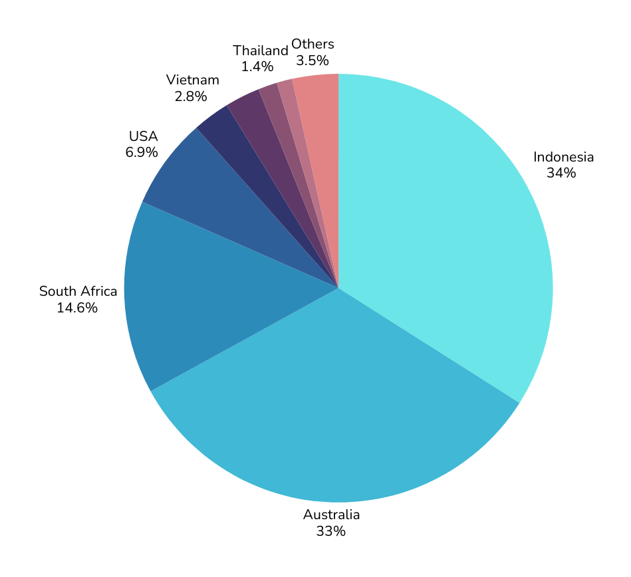

*Data source: The Observer of Economic Complexity*

**Projected Growth in India's Imports of Niobium, Tantalum, and Vanadium Ores and Concentrates (2023–2028).**

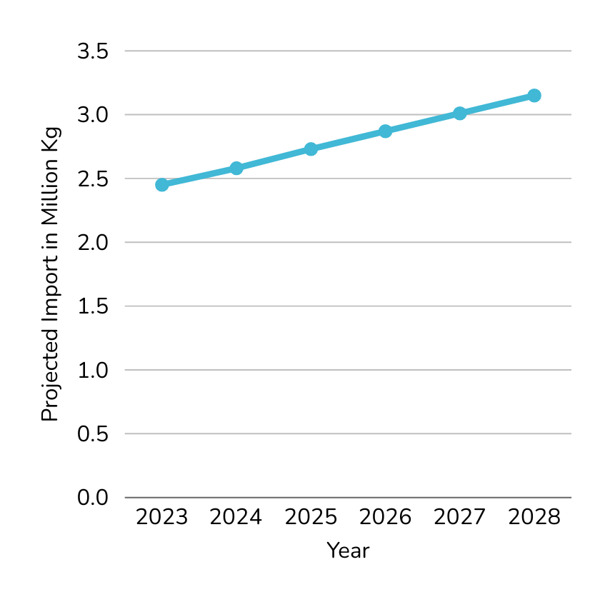

*Data Source: ReportLinker*

Aerospace applications, particularly those involving superalloys, are increasingly reliant on rhenium, a metal with no known domestic production and extracted globally from molybdenite roasting. India’s demand for rhenium in 2023 was approximately 100 kg, primarily for single-crystal turbine blades in fighter jet engines, but the metal remains entirely import-reliant (IEA, 2024, p. 201). Likewise, PGMs, including platinum, iridium, and ruthenium, have applications in radar systems, hydrogen fuel cells, and missile propulsion catalysts. Odisha holds some PGM reserves, but these are not economically viable at scale due to low ore concentration and technological extraction barriers (IBM Yearbook, 2024, Chapter 13, p.2).

The sourcing of these minerals is not merely a commercial exercise but a geopolitical negotiation. Over 75% of global PGM supply originates in South Africa and Russia—both countries prone to labour unrest, regulatory opacity, and, in Russia’s case, sanction-related export disruptions (IEA, 2024, p. 201; Li Pengyuan et al., 2023, p. 15). China continues to dominate the value chain for REEs and vanadium, with its control over refining infrastructure and export quotas presenting a persistent risk to India’s supply resilience (USGS, 2023).

This strategic dependence occurs amidst intensifying global competition for critical minerals. The US, EU, Japan, and South Korea have already instituted dedicated national strategies and alliances, such as the Minerals Security Partnership (MSP) and the EU’s Critical Raw Materials Act, to secure long-term mineral supplies. India’s membership in MSP is a welcome first step, but lacks the forward-deployed institutional depth required to translate diplomatic alignment into industrial security.

Unless India enacts a coordinated mineral security strategy, spanning exploration, processing, international procurement, and R&D substitution, it risks supply-side disruptions that could delay or derail its military modernisation roadmap.

**Mineral-Specific Challenges**

Minerals are not fungible raw materials; each plays a distinct and often irreplaceable role in the structure, propulsion, electronic, or survivability systems of advanced weaponry and aerospace platforms. This section outlines the quantitative gaps, technological dependencies, and geopolitical bottlenecks for each mineral critical to India’s strategic sectors.

**Vanadium**

Vanadium is essential for producing high-strength low-alloy steels used in armour plating, airframe structures, and hypersonic glide vehicles .India is heavily reliant on imports for vanadium, primarily sourced as a byproduct of petroleum refining and slag from vanadium-rich iron ores. China remains the world's dominant producer, accounting for more than 57% of global vanadium output (USGS, 2024, p. 184).

India’s current domestic vanadium production remains negligible, with the Indian Bureau of Mines listing vanadium as a mineral resource yet to be commercially extracted (IBM Yearbook, 2024, Chapter 13, p.4). In 2023, India’s total demand for vanadium stood at approximately 800 tonnes, of which over 780 tonnes were imported, mainly in the form of ferrovanadium (IBM Yearbook, 2024, Chapter 13, p. 5). India’s domestic production remains negligible, as the recovery of vanadium from steel slag and petroleum residues is still under pilot-scale trials and not commercially viable. Moreover, India lacks dedicated stone coal vanadium mines like those exploited in China’s Sichuan Province. The absence of a reliable refining base further exacerbates the risk.

**Hafnium**

Hafnium is used in control rods of naval nuclear reactors, thermal barrier coatings in jet engines, and guidance systems for missiles. India has no known commercial hafnium production. Although hafnium is found as a by-product of zirconium processing, the lack of separation technology and commercial-scale solvent extraction facilities has prevented India from accessing even the secondary resource base (DAE Annual Report, 2023). Annual demand is estimated at 250–300 kg, entirely met through imports from France and the US. Global production is highly concentrated, with AREVA (France) and Materion (USA) dominating the market, both of which are subject to strategic export controls.

**Zirconium**

Zirconium is vital for cladding materials in India’s nuclear-powered submarines and satellite casings. India has one of the largest monazite beach sand reserves globally, with an estimated 19 million tonnes of in situ monazite, containing zirconium as an associated mineral (IBM Yearbook, 2024, Chapter 13, p. 2). However, commercial extraction is limited to less than 150 tonnes annually, versus a demand of over 2,000 tonnes across defence nuclear and aerospace applications (IREL, 2023). This gap is due to under-investment in separation plants and restrictive beach sand mining regulations post-2016.

**Molybdenum**

Molybdenum is used in high-temperature turbine blades, air-breathing hypersonic vehicles, and structural alloys in missiles. India's consumption exceeds 1,200 tonnes per year, all of which is imported—mostly from Chile and the United States (USGS, 2023). India has no identified molybdenum mines. Moreover, molybdenum is increasingly co-produced in copper mines globally, making it vulnerable to copper market fluctuations. A 10% drop in copper prices in 2023 led to a 6.2% decline in global molybdenum output, tightening supplies (S&P Global, 2024).

**Tantalum**

Tantalum is critical in microelectronics used in seeker heads, radar modules, and satellite communication systems. India does not produce tantalum domestically and depends on imports from Rwanda, the DRC, and Brazil—all nations with documented risks of conflict minerals and political instability (OECD, 2023). India’s annual demand is modest (1,000 kg) but highly sensitive to disruptions. Moreover, India lacks traceability mechanisms under the ICGLR-OECD framework, making it susceptible to compliance risks under international norms.

**Tungsten**

Tungsten is indispensable for India’s tank munitions, armour-piercing rounds, and air-launched KEPs (kinetic energy penetrators). Estimated national demand for tungsten exceeds 3,000 tonnes per annum, while domestic output stands at just 250 tonnes, sourced primarily from the Degana deposit in Rajasthan (IBM Yearbook, 2024, Chapter 13, p. 3). With China controlling over 83% of global tungsten supply and India’s extraction impeded by poor beneficiation capabilities, tungsten represents a textbook case of asymmetric dependence in defence-grade metallurgy.

**Niobium**

Niobium is vital for the production of high-strength, low-weight superalloys used in missile airframes, gas turbines, and aerospace fasteners. India's annual demand for niobium is estimated at 500 tonnes, met entirely via imports, mostly from CBMM in Brazil, which supplies over 90% of the world’s niobium (CBMM, 2022). This mono-source supply chain is particularly vulnerable to policy shifts, logistical disruptions, and price manipulation. India does not currently process niobium from domestic tin slags or imported concentrates.

**Rhenium**

Rhenium is one of the rarest elements in the Earth's crust and is used primarily in superalloys for single-crystal turbine blades and rocket thrusters. India has no indigenous production or recycling capacity for rhenium. Demand is small (~100 kg/year) but strategic, particularly for indigenous jet engine development under the DRDO-GTRE program (IEA, 2024, p. 201). Rhenium is extracted as a by-product of molybdenum refining, making its availability doubly constrained in the Indian context.

**Platinum Group Metals (PGMs)**

Platinum, iridium, and ruthenium are used in hydrogen fuel cells, missile propulsion systems, and advanced radar components. India’s annual demand for PGMs in aerospace and defence is projected to be 10–12 tonnes, with imports from South Africa, Russia, and the UK accounting for over 98% of supply (IBM Yearbook, 2024, Chapter 13, p. 2). Domestic PGM reserves are mostly confined to Odisha’s Boula-Naushi ultramafic complex but remain uneconomical to mine due to low ore grades and the absence of specialised metallurgical infrastructure.

**Rare Earth Elements (REEs)**

REEs such as neodymium, dysprosium, samarium, and terbium are foundational to high-performance magnets used in aircraft actuators, missile guidance systems, and AESA radar arrays. India possesses 6.9 million tonnes of monazite reserves, one of the world’s largest, yet remains import-dependent for refined REEs (IREL, 2023). Domestic output (~1,200 tonnes/year) meets less than 20% of total demand, due to the absence of advanced separation and refining infrastructure. China remains the dominant global supplier, responsible for over 85% of rare earth refining capacity (USGS, 2023).

**India’s Current Global Value Chains and Strategic Partnerships**

The criticality of securing dependable mineral supply chains for defence and aerospace production is growing as India attempts to expand indigenous manufacturing of advanced platforms including jet engines, satellites, missiles, and unmanned systems. This imperative is magnified by the fact that India imports over 85 per cent of its defence equipment requirements (SIPRI, 2024), and critical minerals lie at the core of this external dependency. India's current mineral value chains are structured through a fragmented patchwork of imports, with limited refining or separation capacity and near-zero strategic stockpiling. Although India possesses modest reserves of certain critical minerals, such as rare earths and platinum group metals (PGMs), these are not commercially extractable at scale due to low grade or techno-economic constraints (IBM Yearbook, 2024, Chapter 13, p.2).

**Rare Earth Elements (REEs)**

India is moderately endowed with rare earth reserves, primarily in monazite-bearing beach sands along the eastern coastline. However, most reserves remain untapped, with separation capacity restricted to the Indian Rare Earths Ltd (IREL), and even that is focused largely on light rare earths like cerium and lanthanum. India currently imports magnet-grade REEs such as neodymium and dysprosium from China, which dominates over 90 per cent of global rare earth processing (IEA, 2023, p.116). This dependency has constrained the domestic production of permanent magnet motors and radars used in advanced defence and aerospace applications. To mitigate this, India signed a cooperation agreement with Australia in 2022 for critical minerals, covering REEs, cobalt, and lithium, and subsequently invested USD 25 million into Australia’s Critical Minerals Facilitation Office (Australian Government, 2022). Further negotiations under the Quad framework have sought to diversify rare earth processing through a joint India-US-Australia-Japan venture, although no physical infrastructure has materialised yet.

**Platinum Group Metals (PGMs)**

India is the third-largest importer of rhodium globally, with over 31,000 shipments recorded in the past year alone (Volza, 2024a). The country also imports iridium, osmium, and ruthenium in semi-processed form for use in sensors, catalytic systems, and missile coatings (World Integrated Trade Solutions, 2023a). The principal export sources include South Africa, the US, and Germany. However, PGMs remain exposed to significant geopolitical risk. South Africa, which supplies nearly 70 per cent of global PGMs, has faced repeated electricity disruptions and labour disputes, constraining production (IEA, 2024, p.201). India has no bilateral strategic agreement with South Africa specifically addressing PGMs, nor has it secured offtake rights through private-sector investments or sovereign agreements. A new priority should be to engage South African producers such as Anglo American Platinum and Impala Platinum to explore toll refining and partial processing in India, offering tariff concessions in return.

**Niobium**

India is almost entirely dependent on niobium imports for its defence-grade ferroniobium and superalloy requirements, importing primarily from Brazil, which supplies over 90 per cent of global niobium through the state-supported Companhia Brasileira de Metalurgia e Mineração (CBMM). India’s agreements with Brazil, although active through the IBSA framework, do not yet contain provisions for dedicated mineral offtake or joint ventures. In contrast, countries like South Korea and Japan have secured forward purchase agreements with CBMM, gaining preferential access. India must emulate this approach through long-term contracts, especially with the expected rise in domestic consumption of niobium for K-series missiles and Agni-Prime platforms.

**Tantalum, Tungsten and Rhenium**

Tantalum imports are currently sourced from Rwanda and the Democratic Republic of Congo (DRC), with significant concerns over traceability due to conflict mineral risks. India lacks formal engagement with the OECD-aligned Due Diligence Guidance on tantalum and tin supply chains. Tungsten, used in tank penetrator rounds and satellite thrusters, is largely sourced from China and Vietnam. With global supplies becoming volatile due to Chinese export restrictions, India has begun small-scale bilateral engagement with Vietnam, including an MoU signed in 2023 between Khanh Hoa Minerals JSC and the Indian Bureau of Mines for exploration knowledge sharing.

Rhenium, which is critical for high-temperature turbine blades and missile nozzles, is acquired through US and Kazakh intermediaries. The US Department of Defense maintains rhenium in its strategic stockpile and has discouraged exports in certain forms. This underscores the need for India to prioritise rhenium recovery through its own molybdenum circuits at HZL and also explore cooperation with Kazakhstan’s Ulba Metallurgical Plant.

**Treaties and Frameworks for Mineral Cooperation**

India has made progress in multilateral engagement on minerals through its membership in the **Minerals Security Partnership (MSP)**, joining the initiative in 2023. The MSP includes key economies such as the US, Australia, Japan, and the EU, and is aimed at enabling secure, transparent, and sustainable supply chains for critical minerals. Under this umbrella, India can leverage institutional financing and diplomatic support for acquiring stakes in upstream projects. In 2024, India hosted the first Indo-Pacific Critical Minerals Investment Forum in Bengaluru, where deals worth USD 210 million were proposed in REE and tantalum processing across Odisha and Chhattisgarh (MEA Annual Report, 2024).

Furthermore, India has included critical minerals in the scope of its Free Trade Agreements (FTAs) under negotiation with Canada and the UK. The Canada-India Early Progress Trade Agreement (EPTA), currently in its 8th round, includes cooperation on cobalt, lithium, and rare earths. As Canada hosts significant REE separation infrastructure and is a global exporter of hafnium and rhenium, this FTA holds strategic relevance for India’s aerospace ecosystem.

**Mineral-wise Recommendations**

**Vanadium**

**Alternate Chemistries**  
In certain aerospace alloys, niobium and chromium have demonstrated partial substitutability for vanadium. For example, the Ti-6Al-4V alloy, a workhorse in aircraft structures, can be reformulated to use niobium in non-critical applications with lower mechanical stress (DoD Strategic Materials Report, 2023). Further R&D led by DRDO and MIDHANI can explore low-vanadium or vanadium-free high-performance titanium alternatives for specific naval and airframe components.

**Alternate Technologies**  
Advanced extractive metallurgy methods such as redox flow leaching and ion-exchange extraction—already being piloted in Kazakhstan and Canada—offer recovery of vanadium from secondary sources such as oil fly ash and bauxite residue (IEA, 2024, p. 223). India’s petroleum sector, especially BPCL and IOCL, should invest in pilot plants to extract vanadium from desulfurisation by-products. Such circular recovery could support domestic demand for high-strength vanadium-titanium alloys used in hypersonic glide bodies and airframe reinforcement.

**Strengthening Supply Chains**

To secure vanadium, India should target joint ventures with South Africa (13%) and Brazil (8%), which have state-supported producers like Largo Inc. supplying the aerospace-grade vanadium pentoxide used in titanium alloys. These partnerships could be framed within the context of the Mineral Security Partnership (MSP) or via bilateral G2G MoUs.

**Tantalum**

**Alternate Chemistries**  
Research at the Indian Institute of Science (IISc) and ARDE has demonstrated early-stage viability of replacing tantalum capacitors with niobium oxide capacitors in aerospace-grade electronic systems. Although niobium capacitors operate at lower voltages, they can meet certain specifications for UAVs, artillery fire control systems, and radar units, especially if combined with circuit redesign for lower power thresholds (IEEE Journal of Advanced Materials, 2023).

**Alternate Technologies**  
Indian agencies can invest in plasma arc melting technologies, already adopted in Japan and Finland, to recycle tantalum from capacitor-grade e-waste. BHEL and BEL can partner with Finland’s Critical Materials Recycling Platform to trial low-temperature plasma disassociation for metal recovery, particularly from imported avionic systems nearing end-of-life. Japan’s Hitachi has proven success in recovering up to 85% tantalum from ceramic capacitors in 2022 (Hitachi Materials Innovation Report, 2023).

**Strengthening Supply Chains**  
Given the political instability in DRC, India should pursue long-term contracts with Brazil's AMG Brasil and Australia's Global Advanced Metals, both of which are ISO-certified and meet conflict-free supply chain standards. A strategic reserve of 100 tonnes of tantalum oxide, equal to India’s estimated 10-year defence demand, should be established (CEEW Mineral Security Analysis, 2023).

**Tungsten**

**Alternate Chemistries**Though tungsten remains irreplaceable in KEPs due to its high density, recent US Army tests have demonstrated that depleted uranium alloys and hafnium-carbide coatings can outperform tungsten in armor-piercing capabilities, albeit with greater handling risks. India could evaluate this route for limited applications through DRDO-Hyderabad’s ballistic testing labs (Silverado Policy Accelerator, 2023).

**Alternate Technologies**  
In Spain and Austria, enhanced gravity separation and microwave-assisted beneficiation are reducing processing costs for low-grade tungsten ores. India’s Chendapathar and Degana deposits could be reassessed with these technologies under the Geological Survey of India’s critical mineral initiative. A pilot beneficiation unit, jointly developed with IMMT Bhubaneswar and Austria’s MINEX, can be set up to evaluate tungsten ore from pre-identified domestic blocks.

**Strengthening Supply Chains**  
Tungsten’s defence relevance stems from its application in armour-piercing kinetic energy penetrators (KEPs), warhead liners, and rocket engine nozzles. India imports more than 90% of its tungsten needs, with the majority sourced from China (71%), Russia (15%), and Vietnam (6%) (IBM Yearbook, 2024, Chapter 13, p.6). To offset geopolitical risks, India should expedite partnerships with Portugal (W Resources) and the UK (Pryderi Resources) which possess ECHA-compliant mines and are expanding exports to non-Chinese partners.

**Niobium**

**Alternate Chemistries**  
While niobium is considered largely irreplaceable in high-performance alloys, in non-critical systems, titanium-vanadium-aluminium composites can reduce the niobium requirement by nearly 40% (Airbus Materials Substitution Study, 2022). India’s private aerospace players such as TASL and L&T Defence can be incentivised through a new Defence Mineral Substitution Scheme (DMSS) to develop such variants for use in secondary propulsion systems and satellite components.

**Alternate Technologies**  
CBMM’s success with thermomechanical processing of niobium-bearing steel should be replicated in India through tech transfer deals. India’s Steel Authority (SAIL) and MIDHANI could set up a demonstration plant for producing niobium micro alloyed structural steels for naval and aerospace platforms, focusing on high-yield strength at lower mass density (CBMM Technical Whitepaper, 2023).

**Strengthening Supply Chains**  
Niobium’s strategic value lies in its usage in superalloys for rocket nozzles and advanced jet turbine blades. India does not produce niobium domestically and relies entirely on imports, mostly from Brazil’s Companhia Brasileira de Metalurgia e Mineração (CBMM), the world’s dominant niobium producer (over 85% market share) (USGS, 2024, p. 174). A dedicated G2G offtake agreement with CBMM, like those signed with Japan and the US, should be a strategic priority.

**Platinum Group Metals (PGMs)**

**Alternate Chemistries**  
Significant global momentum exists around reducing or replacing PGMs in catalysis and fuel cells. Toyota and Hyundai have pioneered the use of nickel-molybdenum catalysts that reduce platinum loadings by up to 20% in fuel cell vehicles (IBM Yearbook, 2024, Chapter 13, p. 4). Similarly, ruthenium-based resistors have replaced palladium-silver resistors in high-voltage defence electronics. India should replicate the DOE's H2@Scale initiative by launching a National PGM Substitution Fund to scale rhenium- and molybdenum-based catalysts.

**Alternate Technologies**  
Recycling remains the most promising near-term option. Urban mining initiatives in Japan and the EU have demonstrated recovery rates above 90% for PGMs from used auto-catalysts and aerospace scrap (OECD Urban Mining Report, 2023). India must mandate reverse logistics standards in automotive and aerospace sectors and support tech pilots in partnership with firms such as Johnson Matthey or Umicore. CSIR-NML and IIT-Bombay can be tasked with adapting hydrometallurgical and bioleaching techniques for PGM extraction from scrap.

India’s defence and aerospace sectors are navigating a perilous strategic inflection point—where the ambition for indigenous technological prowess is increasingly constrained by acute mineral insecurity. A mineral security strategy for India must go beyond passive procurement and adopt a full-spectrum approach: strategic stockpiling, upstream offtake agreements, domestic processing, targeted recycling, and accelerated R&D on substitution.

**Strengthening Supply Chains**  
India’s PGM import dependency is over 95%, primarily sourced from South Africa (rhodium, iridium, platinum) and Russia (palladium). In 2023, India imported over 11,953 shipments of rhodium and 525 shipments of iridium (Volza, 2024a). Persistent power outages in South Africa and geopolitical disruptions in Russia render India’s PGM supply chain acutely vulnerable (IEA, 2024, p. 201). Strategic stockpiling, combined with joint exploration with Canada and Finland (hosts of emerging PGM projects like the Marathon and Sakatti), should be immediately pursued.

**Works Cited**

* Australian Government. (2023). *India-Australia Critical Minerals Cooperation Framework.* Government of Australia. DOI: <https://international.austrade.gov.au/en/news-and-analysis/news/australia-india-economic-cooperation-and-trade-agreement-ai-ecta-critical-minerals>
* CBMM. (2022). *Companhia Brasileira de Metalurgia e Mineração: Annual Report.* DOI:<https://qa.cbmm.com/relatorio-sustentabilidade/assets/files/2022/cbmm-sustainability-report-2022-eng.pdf>
* DAE. (2023). *Annual Report 2022–2023.* Department of Atomic Energy, Government of India. DOI: <https://cdnbbsr.s3waas.gov.in/s35b8e4fd39d9786228649a8a8bec4e008/uploads/2023/10/20231019477169214.pdf>
* IBM Yearbook. (2024 [2022]). *Indian Minerals Yearbook: Strategic Minerals (Chapter 13).* Indian Bureau of Mines, Ministry of Mines. February 2024. DOI: <https://ibm.gov.in/writereaddata/files/171817703066694d06a2210IronSteel_Scrap_Slag_IMYB_2022.pdf>
* IEA. (2023). *The Role of Critical Minerals in Clean Energy Transitions.* International Energy Agency. DOI: <https://www.iea.org/reports/critical-minerals-market-review-2023>
* IEA. (2024). *Global Critical Minerals Outlook 2024.* International Energy Agency. DOI: <https://www.iea.org/reports/global-critical-minerals-outlook-2024>
* IREL. (2023). *Annual Report 2022–2023.* Indian Rare Earths Limited. DOI: <https://irel.co.in/documents/20126/853325/Annual+Report+of+IREL+for+FY+2022-23.pdf/0c65d452-5e60-2c2d-a536-d3717be9bf58?t=1735304248288>
* Li, P., Liu, Q., Zhou, P. & Li, Y. (2023). *Mapping global platinum supply chain and assessing potential supply risks.Frontiers in Energy Research*, 11. DOI: <https://www.frontiersin.org/articles/10.3389/fenrg.2023.1033220/full>
* MEA. (2024). *Annual Report 2023–2024.* Ministry of External Affairs, Government of India. DOI: <https://www.mea.gov.in/Images/CPV/38005_Final-MEA-AR-2023-English.pdf>
* OECD. (2023). *Due Diligence Guidance for Responsible Supply Chains of Minerals from Conflict-Affected and High-Risk Areas.* DOI: <https://www.oecd.org/en/publications/monitoring-and-evaluation-framework_55e09ce0-en.html>
* S&P Global. (2024). *Impact of Copper Price Fluctuations on Associated Critical Mineral Supply.* DOI: [https://www.spglobal.com](https://www.spglobal.com/)
* SIPRI. (2024). *Trends in International Arms Transfers 2023.* Stockholm International Peace Research Institute. DOI: <https://www.sipri.org/databases/armstransfers>
* USGS. (2023). *Mineral Commodity Summaries 2023.* U.S. Geological Survey. DOI: <https://doi.org/10.3133/mcs2023>
* USGS. (2024). *Mineral Commodity Summaries 2024.* U.S. Geological Survey. DOI: <https://doi.org/10.3133/mcs2024>
* VIF. (2022). *India’s Strategic Materials: Challenges and Prospects.* Vivekananda International Foundation. DOI: <https://www.vifindia.org/article/2022/november/03/india-s-strategic-materials-challenges-and-prospects>
* Volza. (2024a). *Rhodium Imports in India – Market Size & Demand.* Volza. DOI: <https://www.volza.com/p/rhodium/import/import-in-india>
* World Integrated Trade Solutions. (2023a). *India: Iridium, Osmium and Ruthenium Semi-Manufactured Imports by Country in 2023.* World Bank. DOI: <https://wits.worldbank.org/trade/comtrade/en/country/IND/year/2023/tradeflow/Imports/partner/ALL/product/711049>